**GAME- JACK THE GIANT**

**ABSTRACT**

JACK THE GIANT is a game which is developed on unity editor . Unity editor is made to empower you to create the best interactive entertainment or multimedia experience that you can. Unity editor is a tool which used for animation specially games . It is also used for creating different scenes . It is a feature rich and highly flexible editor. The Unity engine is loved throughout the gaming industry for the depth and quality of its optimizations and the speed and efficiency of its workflows – allowing Unity users to produce high-end content fast.

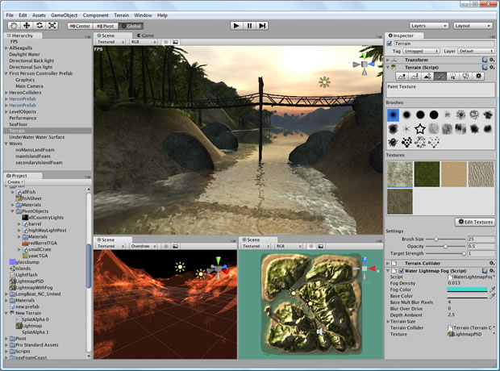

In backend c# language is used for coding . Sound effects, assets, backgrounds were used.

This game is single player game containing mainly four options:-

1. Start game
2. High score
3. Options
4. Quit
5. Start game – This option is used for playing the game.
6. High score - This option stores the highest score made by multiple players.
7. Options – This option provides player to change the mode of the game.ie whether player wants to play in easy, medium or hard mode.
8. Quit – This option provide player to exit from the game.

Software used:-

Unity editor

Language used :-

C#(sharp)

Student name:- Mentor:-

Soni Kumari Mrs Rubal Deep Gill

Sr.Lecturer